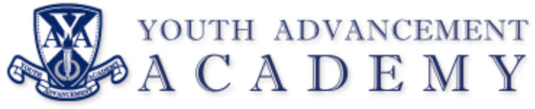

REGULAR BOARD MEETING
Chime School
6750 Chime St.
Kalamazoo, MI 49009
Tuesday, March 12, 2024
5:30 PM

AGENDA

I. Call to Order Regular Meeting

II. Pledge of Allegiance

III. Roll Call

IV. Approval of Agenda

V. Public Comment – (five minute maximum)

VI. Approval of Minutes
February 13, 2024, Regular Meeting

VII. Communications
Director’s Report

VIII. Regular Agenda
- Letter from Township Attorney: Dr. Hamlin
- Financial Report: Dr. Magnuson
- School Facilities Update: Todd Mora

IX. Public Comment (non-agenda items)

X. Board Comments

XI. Adjournment

Next Meeting: April 9, 2024 (Chime School)

